**Chestertown Rotary Club Washington College Rotaract Club**

[](http://www.google.com/url?sa=i&rct=j&q=&esrc=s&source=images&cd=&cad=rja&uact=8&ved=0ahUKEwiy8OqXmLTLAhUIyj4KHamLB6EQjRwIBw&url=http://www.underconsideration.com/brandnew/archives/new_logo_and_identity_for_rotary_by_siegelgale.php&psig=AFQjCNFSowrL8x8wUogEmlyenu8jCmpqjA&ust=1457632978952885) **[](http://www.google.com/url?sa=i&rct=j&q=&esrc=s&source=images&cd=&cad=rja&uact=8&ved=0ahUKEwjtn7Ogl7TLAhVMez4KHX2WCosQjRwIBw&url=http://www.rotaractpanvelmidtown.org/downloads.html&bvm=bv.116274245,d.cWw&psig=AFQjCNGGr78WOxsVv9CuU5poqjP_sCoa4Q&ust=1457632548575925)**

**Flags for Heroes**

**Honoring Community & Country**

**[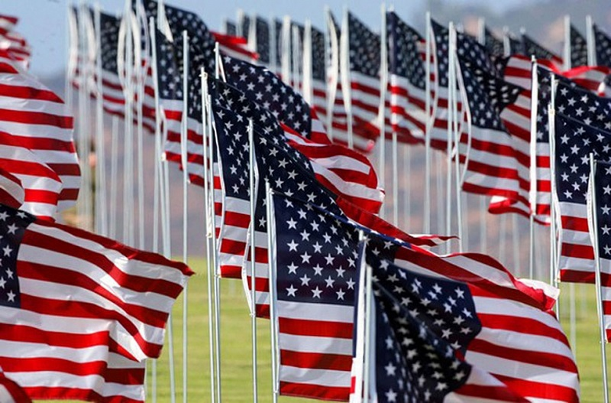](http://www.google.com/url?sa=i&rct=j&q=&esrc=s&source=images&cd=&cad=rja&uact=8&ved=0ahUKEwjMvbX1xLTLAhWENj4KHVWSBk4QjRwIBw&url=http://all-that-is-interesting.com/evolution-american-flag&psig=AFQjCNE7cV-9vAbzeCAmmWR0ca4200SZhQ&ust=1457642672311845)**

**O say, does that star-spangled banner yet wave  
O'er the land of the free and the home of the brave?**

**-- Francis Scott Key**

**Sponsor a Flag for $50**

* **Honor a personal hero - a veteran, member of our armed forces, health care worker, police officer, firefighter, family member, teacher, or friend who has made a positive impact on your life. Flags are a full sized 3x5 ft. and stand 8 ft. tall.**
* **Flags will be proudly displayed on Washington College’s parcel located at Washington Avenue and Morgnec Road from mid-May through Memorial Day Weekend.**
* **A list of flag sponsors and their heroes will appear in local publications for Memorial Day Weekend.**
* **100% TAX DEDUCTIBLE. Proceeds will support local veteran and other worthy causes.**

**Sponsor Name(s) _____________________________ Mailing Address ________________________________**

**City _________________________________ State _____ Zip ________ Phone _____-_____-___________**

**Email Address _______________________________________________________________________________**

**Corporate sponsor: $250 - Please identify up to 5 heroes and type of any military service on reverse side.**

**Individual sponsor: # of flags ______ Total contribution ($50/flag): $_____________________________**

**Name(s) of Hero(es) (1)______________________________ (2)_________________________________**

**Please note by the corresponding number(s) above if your hero(es): ________ died in service of the U.S.; ________ otherwise served in the U.S. military; or ________ currently serves in the U.S. military.**

**DETAILS WELCOMED!!! IF MORE THAN TWO HEROES, PLEASE PROVIDE INFORMATION ON REVERSE SIDE.**

**_______ Check this space if you would like to sponsor a flag generally for “All of the brave men and women who have served and presently serve our country.”**

**The Chestertown Rotary Flags for Heroes Fund is a component fund of the Mid-Shore Community Foundation, a public 501(c)(3) charity (EIN: 52-1782373). Contributions to the Fund are fully tax-deductible as allowable by law. A copy of MSCF’s financial statement is available at mscf.org or by calling 410-820-8175. Information about MSCF submitted under the Maryland Charitable Solicitations Act can be obtained from the office of the Secretary of State, State House, Annapolis, MD 21401. Chestertown Rotary Club retains all ownership rights in and to the subject flags for use in future projects and reserves sole and absolute discretion to reject any submission deemed inappropriate.**

**Make checks payable to: MSCF/Chestertown Rotary Flags for Heroes Fund**

**Mail to: Chestertown Rotary Flags for Heroes**

**c/o Andrew C. Meehan**

**110 North Cross Street**

**Chestertown, MD 21620**

**For more information or to pay securely online by credit card go to**

**www.chestertownrotaryflags4heroes.com**

**ORDERS MUST BE RECEIVED BY FRIDAY, 5/16/2025 Questions? Email Andy Meehan at ameehan12@gmail.com**